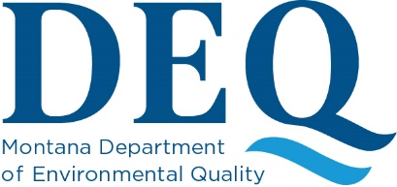

2026 PTCS Consultants Days
April 16-17, 2026 – Fairmont Hot Springs
Tentative Topics to Include:
- DEQ
  - Updates
  - RIs
  - CSMs
  - RAAs
  - Cleanups
  - Closures
- Aestus
  - “Optimizing LNAPL Remediation at a Fractured Bedrock Site Using Electrical Hydrology”
  - “Beginning with the End in Mind: Financially Responsible Approach to Site Characterization to Improve Remedial Outcomes”
- Regenesis
  - Product Types and Applications.
  - Sampling wells with after PetroFix Application.

- Tersus
  - Products for remediation of petroleum hydrocarbons as well as sites with chlorinated solvents.
- DEQ Brownfields
  - Eligibility requirements and determinations.
- Energy Labs
  - Lab process and overview with Q/A.
- Water and Environmental Technologies (WET)
  - Air Sparge/Soil Vapor Extraction (AS/SVE) case studies.
- Resource Technologies, Inc. (RTI)
  - Yellowstone truck spill follow-up with CalClean.

Note: Content and schedule may change based on availability

